**AIM:** Write a C program to Graph traversal using Depth First Search

**ALGORITHM:**

1. Start from a given source vertex.
2. Mark the vertex as visited and print it.
3. Recursively visit all adjacent unvisited vertices.
4. Continue until all vertices reachable from the source are visited.

**CODE:**

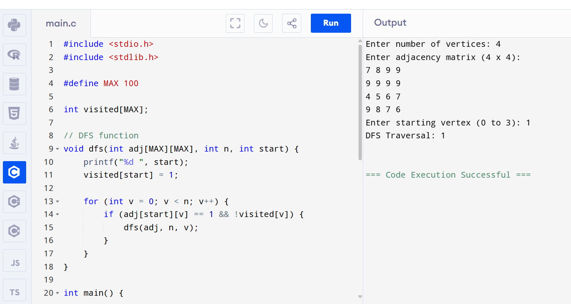

**OUTPUT:**

Enter number of vertices: 4

Enter adjacency matrix (4 x 4):

7 8 9 9

9 9 9 9

4 5 6 7

9 8 7 6

Enter starting vertex (0 to 3): 1

DFS Traversal: 1